Empowering Adult Learners of Basic Skills

Discussion Forum Suggestions

# Discussion Forums

There are a number of discussion forums in each course. These are currently empty. As a facilitator, you can add the topics you wish here. We have listed suggested topics for each forum.

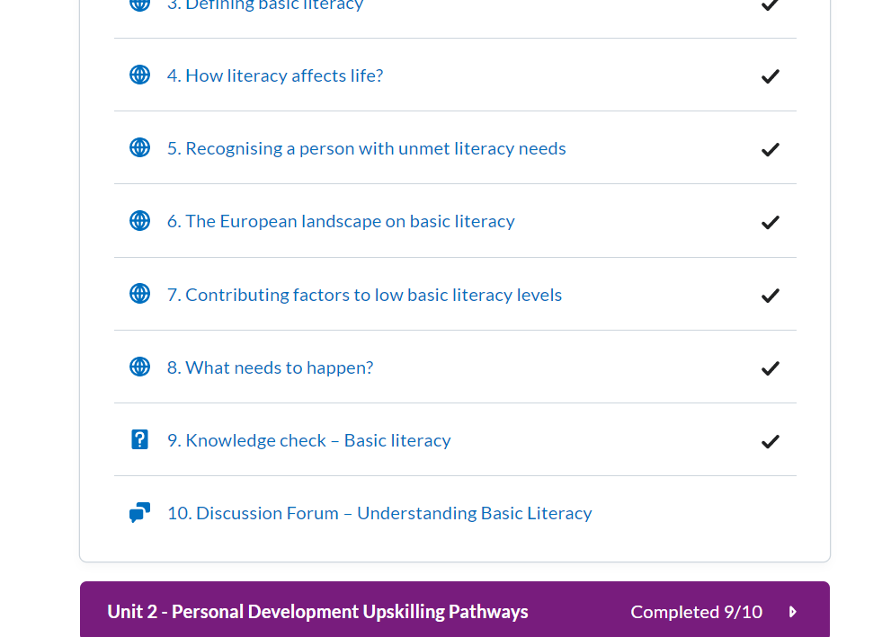

# How to use discussion forums

Click on the Discussion topic and **start a new thread** to edit

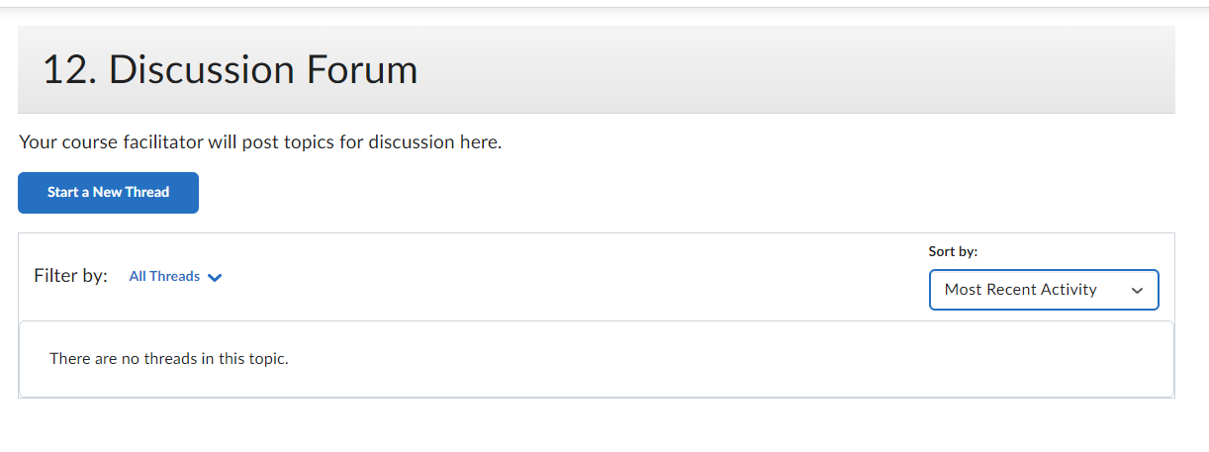

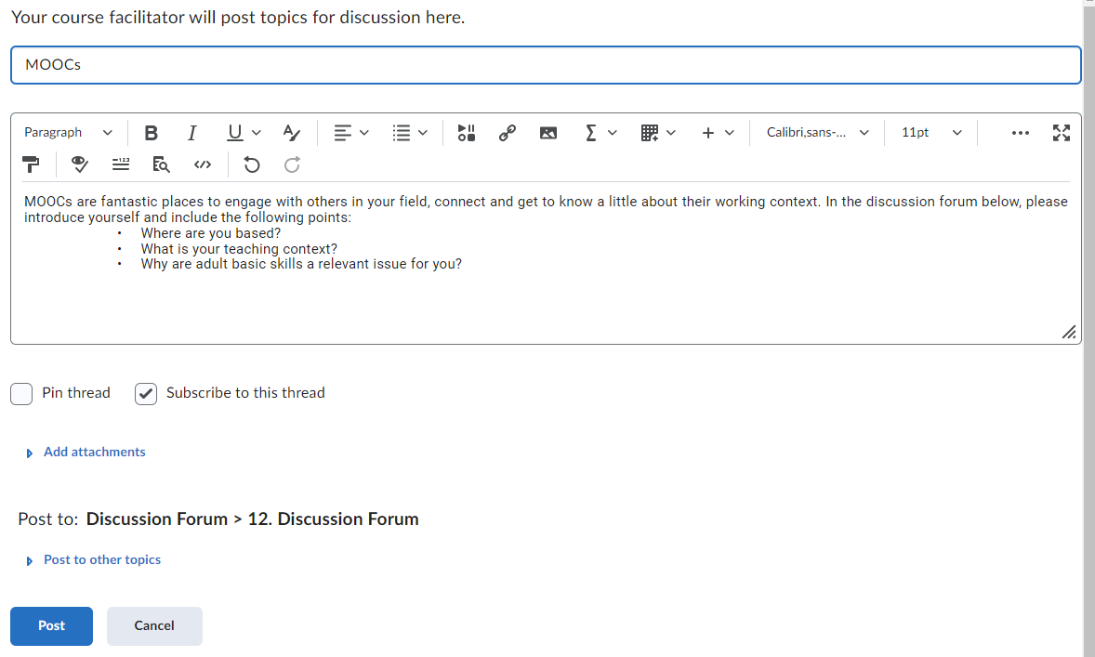

Click **‘post’** to create the topic

# Badges:

Learners will get a Digital badge if they post in each discussion forum. They can either reply to a thread or start their own thread.

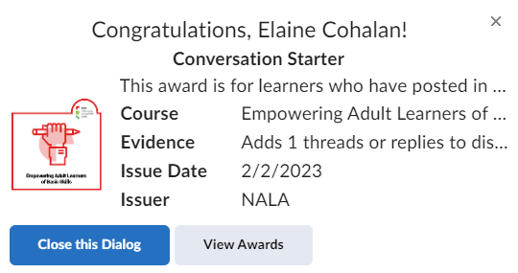

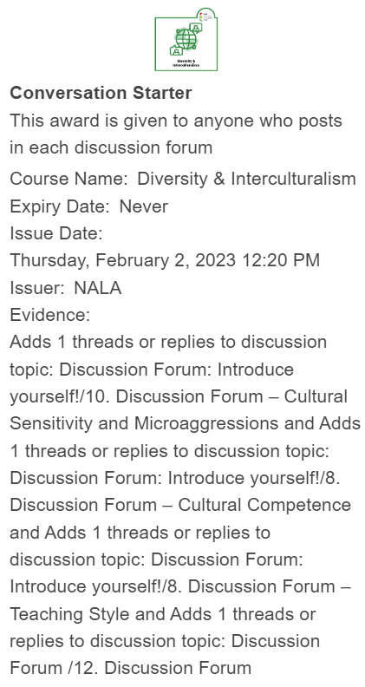

*Unit 1:*

*10.* *Discussion Forum – Understanding the learning environment*

Topics suggested for discussion:

1. MOOCs are fantastic places to engage with others in your field, connect and get to know a little about their working context. In the discussion forum below, please introduce yourself and include the following points:

• Where are you based?

• What is your teaching context?

• Why are adult basic skills a relevant issue for you?

2. The diagram above illustrates some aspects of the learners’ contexts that should be considered and drawn on in the curriculum development process.

In the discussion forum below think of any other contexts which should be considered which are related to your own teaching context

[Note: link to purple learner contexts diagram]

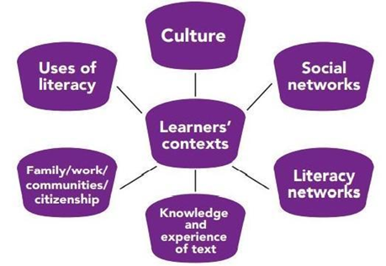

*Unit 2:*

*7.* *Discussion forum – Best Practice Teaching for Basic Skills*

Topics suggested for discussion:

1. Choose one European best practice in adult learning and basic skill development that you feel relevant to your work, context. Share your choice and explain its relevance.

2. Take the [DigCompEdu CheckIn](https://ec.europa.eu/eusurvey/runner/CheckIn_HE_v2021_EN) self-assessment. What is your experience? How much does it reveal areas with development potential for your own digital skills?

3. Choose a literacy blog that interests you, check it out, and think of ways how you could implement some of their ideas and suggestions into your own teaching practice. Share your findings with the group!

*Unit 3:*

*9.* *Discussion forum - Personal Development Upskilling Pathways*

Topics suggested for discussion:

1. What do you know about your country's situation on the subject of adults’ skills and participation in adult learning? Endeavour to compare beliefs and research-based evidence!

The [*Adult education in Europe 2019 - A civil society view*](https://eaea.org/wp-content/uploads/2019/12/Country-Reports-2019.pdf) EAEA report offers you country specific information.

2. What do you know about your country's status regarding the implementation of the Upskilling Pathways recommendation?

Look into the Eurydice report on [*Adult education and training in Europe – building inclusive pathways to skills and qualifications*](https://op.europa.eu/en/publication-detail/-/publication/827fcd9c-1a8c-11ec-b4fe-01aa75ed71a1/language-en/format-PDF/source-232128473) for country specific information and European comparison.

3. Which of the three steps of Upskilling Pathways represents the highest challenge in your country?

4. How much do (or could) you apply the three-step approach in your work as a tutor?

5. Look into and take the CITO[SkillsChecker](https://www.skillschecker.ie/)! How relevant and useful do you find this tool? Could you use it in your context?

*Unit 4:*

*9. Discussion Forum final Activity: My empowerment plan*

Topics suggested for discussion:

1. NALA Case Study: In the discussion forum think about the strategies Elaine implements and how what she does may be similar to what you do in your context. Comment on and reflect upon whether there was an aspect of what Elaine’s case study that resonates with you.

2. My Empowerment Plan: Post your empowerment plan and comment on at least 2 x peers’ work. How did you find the task? What did you take from it?